## 

## 

The Impact of Urban Sprawl on Access to Secondary Schools in Chinese Cities

## 

Robert Wang, Prof. René D. Flores

## 

## 

## 

## Abstract

China has experienced rapid urbanization and urban sprawl since the 1970s, while also placing significant emphasis on secondary school education. However, limited research exists on the city-specific impact of urban sprawl on access to secondary schools in China. This study aims to address this gap by employing regression models to examine how various factors of urban sprawl influence access to secondary education in Chinese cities using 2014 data. Additionally, a neural network model and time series regressions are utilized to predict cities that may face education access challenges due to urban sprawl. The findings reveal a negative relationship between urban sprawl and access to secondary schools, as indicated by the regression models, although the accuracy of the models is not perfect. Furthermore, a list of cities at risk of education access issues due to urban sprawl is generated using the neural network model, necessitating further investigation to validate the impact on secondary school access in these cities. This study sheds light on the implications of urban sprawl for secondary education and emphasizes the need for targeted interventions and policies to ensure equitable access amidst urbanization in China.

## Introduction

Urban sprawl is a complex and multifaceted phenomenon characterized by the outward expansion of urban areas, resulting in low-density, automobile-dependent development patterns and the conversion of rural land into built-up areas.[1] It poses significant social, economic, and environmental challenges for cities and their surrounding regions. Understanding the causes, consequences, and potential solutions to urban sprawl is crucial for sustainable development and the well-being of urban populations.

Urban sprawl has been a prominent phenomenon in China since the 1970s, driven by rapid urbanization and population growth.[2] As cities expand and spread, they bring about a myriad of social, economic, and environmental changes that have far-reaching implications for various aspects of urban life. One critical aspect is the impact of urban sprawl on access to education, particularly secondary schools, in Chinese cities.

Education holds significant importance in Chinese society, with a strong emphasis on academic achievement and the pursuit of higher education.[3] However, the effects of urban sprawl on education, especially at the secondary school level, remain relatively underexplored, particularly on a city-by-city basis. Understanding how urban sprawl influences access to secondary schools is crucial for ensuring equitable educational opportunities and addressing potential disparities arising from urban expansion.

This research aims to address this knowledge gap by investigating the relationship between urban sprawl and access to secondary schools in Chinese cities. By analyzing data from 2014 and employing regression models, this paper seeks to identify the key factors within urban sprawl that affect education access. Additionally, this paper employs a neural network model and time series regressions to predict cities that may face challenges in educational access due to urban sprawl.

By examining the impact of urban sprawl on secondary education on a city-by-city basis, this study contributes to the understanding of the educational consequences of urban expansion in China. It also provides insights into the factors influencing educational access and highlights the need for targeted interventions and policies to ensure equitable educational opportunities amidst urban growth. Ultimately, the findings of this research can inform urban planning strategies and educational policies to mitigate the potential negative effects of urban sprawl on access to secondary schools in Chinese cities.

## Settings and Context

To comprehend urban sprawl in China, it is essential to delve into the factors that have propelled its occurrence. From the late 1970s onwards, Deng Xiaoping enacted a variety of market reforms to boost the Chinese economy and encourage industrialization. These reforms resulted in a substantial increase in China's economic growth rate, surging from approximately 6% before 1978 to over 9% afterward, with peaks reaching 13% and 15%.[4] The heightened productivity facilitated job creation as industries expanded and required additional labor. Simultaneously, the reforms led to the de-collectivization of farms, fostering more efficient family farming practices and reducing the agricultural workforce.[5] Consequently, a larger number of individuals were able to migrate from rural areas to urban centers. In addition, while analyzing migration data in 1987 and 1990, Liang states that “Migrants from rural origins increasingly choose cities as destinations.”[6] With the new influx of migrants pouring into Chinese cities, Chinese cities had to rapidly expand to accommodate all of the people, setting up the foundation for urban sprawl in China.[7]

As of the present, China is one of the largest countries in the world, with a population of 1.4 billion people and a land area of 9.7 million square kilometers.[8] However, the growth rate of China’s population has been steadily declining since the 1970s due to the one-child policy implemented in the same time period. This policy aimed to encourage families to have only one child through a range of incentives, including preferential access to housing, schools, and healthcare services. Discouragement of larger families involved financial levies on additional children and various sanctions, ranging from social pressure to limited career prospects, particularly in government jobs.[9] As a result, China’s population growth rate began to steadily decline. Since one potential marker for urban sprawl is decreased population growth, China could possibly face even more pronounced effects of urban sprawl in the coming years.

To understand the usage of secondary schools as a measurement of access to education, one must first understand the Chinese education system. The Chinese education system consists of a mandatory six years of primary school, another mandatory three years of lower secondary school, an optional three years of upper secondary school, and university.[10] Since primary school is mandatory, it would not be as useful to track it as an indicator of access to education. Additionally, a significant proportion of Chinese students opt to study abroad for university, with nearly four times the number of students studying abroad compared to secondary school enrollment.[11] In addition, secondary school is when Chinese students take the *Gaokao*, a college entrance exam that is viewed as a significant determinant of a student’s future success.[12] Failing to take the Gaokao severely limits job opportunities for students. By comprehending the effects of urban sprawl on secondary school access, a clearer understanding can be gained regarding cities facing greater challenges in providing equitable education opportunities.

## Literature Review

Due to the importance of urban sprawl and access to education, numerous papers have been published on the topics. The current literature surrounding the two topics have developed in their respective fields, but have yet to combine.

While there are many papers analyzing urban sprawl, one constant among the papers is that they highlight the difficulty in defining urban sprawl. In all of the papers on urban sprawl, they highlight how urban sprawl is composed of numerous components and can be defined in a variety of ways. In fact, Bhatta et. al’s paper is focused on the various methods of defining urban sprawl and their pros and cons.[13] Among urban sprawl literature, it can be difficult to compare results due to the difference in how urban sprawl is examined. However, spatial and population parameters are frequently used in definitions of urban sprawl. Li et. al’s paper focuses on the spatial and population parameters of urban sprawl, using urban sprawl index (city area growth percentage minus city population growth rate) as a metric for urban sprawl to analyze how various socioeconomic factors affected urban sprawl, which inspired the use of the urban sprawl index in this paper.[14] In addition to Li et. al’s paper, Liu et. al’s paper also analyzes urban sprawl on a city by city basis, looking at how city population size affects urban sprawl.[15] Like Li et. al, Liu et. al uses a similar urban sprawl metric taking into account city area growth rate and population growth rate. In Wang et. al’s paper, they also analyze urban sprawl between cities, though the paper compares different regions of China as opposed to comparing individual cities.[16] Wang et. al uses population density and land density metrics to analyze urban sprawl. Although Wang et. al do not use growth rates, they still use spatial and population parameters to measure urban sprawl. Again, it is important to acknowledge that the studies paint a limited picture of urban sprawl, as urban sprawl encompasses more than just spatial and population parameters.

When analyzing education, especially in relation to urban sprawl, there is a distinct lack of literature that analyzes cities at an individual level. Instead, many research papers analyze education either as a whole, on a region by region basis, or as a general urban vs rural divide. In Rong’s et. al’s paper, they analyze various metrics that lead to inequality in education, such as race, gender, region, and level of urban development.[17] One of Rong et. al’s conclusion was that the vast majority of the illiterate population in China lived in rural areas.[18] Xiang et. al’s paper analyzes the urban/rural divide in education more closely, again concluding that rural areas have significantly less access to education than urban areas.[19] The paper continues by discussing how though there is an increase in schools in rural areas, the increase does not do much to overcome the significant divide in education levels between urban and rural areas.[20] Ayoroa et. al’s paper again discusses how rural areas have many indicators of a subpar education such as a high dropout rate, low quality of teachers, and low enrollment.[21] However, Ayoroa also mentions infrastructure development as a method for improving the quality of education in rural areas, setting up the question of how the uncontrolled infrastructure development that comes with urban sprawl could affect education.

While there are several papers analyzing urban sprawl and education in China, almost none of the papers explicitly analyze the effect of urban sprawl on education, and none of the papers examine the effect of urban sprawl on education on a city by city basis. However, the city by city analysis in urban sprawl studies helped set up the analysis conducted in this paper. In addition, the focus on the urban/rural divide in education leads to the further question of how urban sprawl, as a middle ground between urban and rural, affects education.

## Dataset Overview

The dataset was acquired from China Data Online, an online Chinese data repository run by China Marketing Research Co. Ltd and the University of Michigan’s China Data Center. The dataset is in the “Prefecture” section of the “Yearly Statistics” section of the “City Statistics” section of the website. The data in the dataset is acquired from the National Bureau of Statistics in China and several other government agencies and private sources. The entire database contains many datasets, but the data used for this research was the dataset on yearly statistics by prefecture. The dataset covers the time period between 1996 to 2021. Within this dataset, data on each province can be collected, which contains data on individual cities.

To collect data from the dataset, an excel file is downloaded for each variable and each province. The file contains data on the variable for each city in the province over the course of 1996 to 2021. In total, 30 excel files had to be combined to create a dataframe for each variable, representative of each province in China. The variables taken from the dataset include: Land Area (10000 sq km), Population (10000 people), Number of Public Transportation Vehicles, Natural Growth Rate, Number of Secondary Schools, and Student Enrollment in Secondary Schools (10000 people). Since the number of public transportation vehicles has many values missing beyond 2014, the analysis is performed in the year 2014. The other variables have values missing in their datasets as well, but those missing values are later than 2014.

To create the final dataset used for data analysis, various dataframes were manipulated to obtain the correct variables used for the final analysis. The data on transportation is divided by the population data to get the Number of Public Transportation Vehicles Per 10000 People. Land Area Growth Rate is obtained by dividing the Land Area in 2014 by the Land Area in 2013, subtracting one from the result, and multiplying the result by 100. Number of Secondary Schools Per 10000 Sq KM is obtained by dividing the number of schools by the land area. Proportion of Population Enrolled in Secondary Schools is obtained by dividing student enrollment in secondary schools by the population. These variables were combined in a single dataframe.

## Methods

To analyze the relationship between urban sprawl and access to secondary schools, three linear regressions are run using the linregress function in the scipy.stats library, with the x values being each variable relating to urban sprawl and the y value being the proportion of people enrolled in secondary schools. For each linear regression, first, a scatterplot is modeled with the x and y values using matplotlib. Then, the slope, intercept, r-squared, p-value, and standard error are calculated for each regression and then modeled using matplotlib.

After the linear regressions were run, a multiple regression was run on the urban sprawl variables to see which variable is the best indicator for the proportion of the population enrolled in secondary school. First, a separate dataframe was made with only the urban sprawl variables. The dataframe was then standardized using the StandardScaler function in the sklearn.preprocessing library to remove the mean for each column and scale each column to unit variance. Then, a constant was added to the scaled dataset using the statsmodels.api library since each graph had a similar y-intercept. Finally, the OLS function in the statsmodels.api library was used to create a multiple regression. The same process was repeated without the standardization step to create a non-standardized model.

Following the multiple regression, a neural network is trained on the data. The model is a feedforward neural network model made with the keras library. The neural network generates a probability that a city has a low access to education (less than 3.2 percent of the population is enrolled in secondary school). 3.2 percent represents the bottom 5th percentile of cities. The neural network consists of an input layer with three dimensions, a hidden layer with 12 nodes utilizing the sigmoid activation function, a hidden layer with 12 nodes utilizing the relu activation function, another hidden layer with 12 nodes utilizing the sigmoid activation function, and an output layer with 1 unit with linear activation. The loss function is Mean Squared Error, and the optimizer used is Adam. The neural network is run using 500 epochs with a batch size of 50. The specific parameters of the neural network were determined by experimenting with different parameters and selecting the ones that gave the best performance.

The data is randomly split into training and testing data with the training data being twice as large as test data. The neural network is modeled on the training data and evaluated using the test data. The various datasets from China Data Online are then projected forward to 2025 using linear regressions with statsmodel. The projections are then combined into a dataset in the same manner as the 2014 dataset. The resulting data is then fitted with the neural network, generating a list of cities that may have future issues with secondary school access due to urban sprawl.

## Results

### Linear Regressions

*Slope: -0.00033*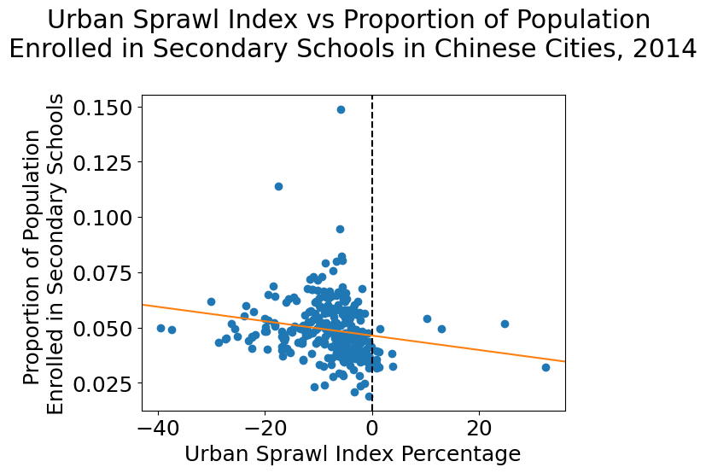

*Intercept: 0.046*

*R-squared: 0.035*

*P-value: 0.0016*

*Standard error: 0.00010*

**Figure 1.** Scatter plot of urban sprawl index vs. the proportion of the population enrolled in secondary school, with an orange line indicating the linear regression. To the right of the graph is a summary of various statistics regarding the linear regression.

The relationship between the urban sprawl index and the proportion of the population enrolled in secondary school can be described with the equation $y = -0.00033x+0.046$. There is a negative correlation between urban sprawl and the proportion of the population enrolled in secondary school, as seen by the negative slope of the regression line. While the R-squared value is low, signaling that the model only explains a small portion of the variability in the data, the P-value is well below 0.05, signifying that the negative correlation is most likely not due to chance.

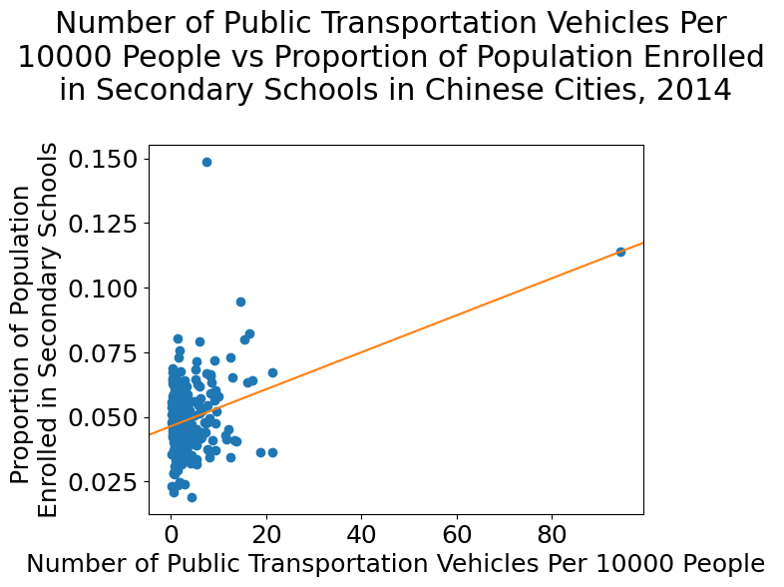

*Slope: 0.00072*

*Intercept: 0.046*

*R-squared: 0.12*

*P-value: 1.49 * 10-9*

*Standard error: 0.00011*

**Figure 2.** Scatter plot of the number of public transportation vehicles per 10,000 people vs. the proportion of the population enrolled in secondary school, with an orange line indicating the linear regression. To the right of the graph is a summary of various statistics regarding the linear regression.

The relationship between the number of public transportation vehicles per 10,000 people and the proportion of the population enrolled in secondary school can be described with the equation $y = 0.00072x+0.046$. There is a positive correlation between the number of public transportation vehicles per 10,000 people and the proportion of the population enrolled in secondary school, as seen by the positive slope of the regression line. While the R-squared value is low, signaling that the model only explains a small portion of the variability in the data, the P-value is well below 0.05, signifying that the positive correlation is most likely not due to chance. Due to the outlier in the graph, the regression was run again with the outlier dropped to see if there would be any significant deviations. In the new regression, the slope and intercept were essentially unchanged. In addition, the R-squared value was 0.04, the p-value was 0.00047, and the standard error was 0.00020. The outlier does not skew the data, and primarily serves to reinforce the positive correlation.

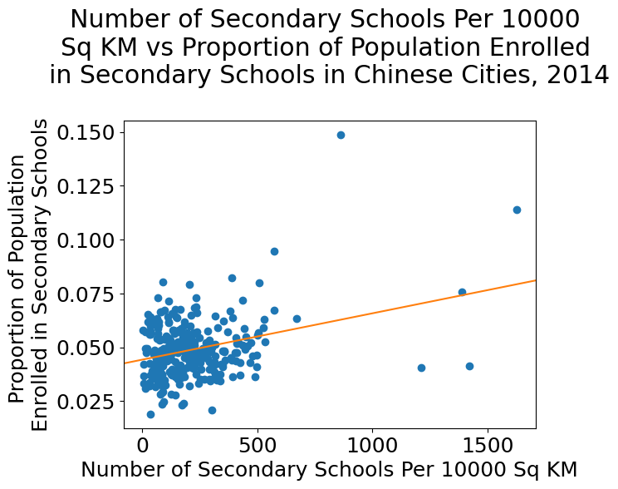

*Slope: 2.15 * 10-5*

*Intercept: 0.044*

*R-squared: 0.10*

*P-value: 3.57 * 10-8*

*Standard error: 3.80 * 10-6*

**Figure 3.** Scatter plot of the number of secondary schools per 10,000 sq KM vs. the proportion of the population enrolled in secondary school, with an orange line indicating the linear regression. To the right of the graph is a summary of various statistics regarding the linear regression.

The relationship between the number of secondary schools per 10,000 sq KM and the proportion of the population enrolled in secondary school can be described with the equation $y = 2.15*10^{-5}x+0.044$. There is a positive correlation between the number of secondary schools per 10,000 sq KM and the proportion of the population enrolled in secondary school, as seen by the positive slope of the regression line. While the R-squared value is low, signaling that the model only explains a small portion of the variability in the data, the P-value is well below 0.05, signifying that the positive correlation is most likely not due to chance.

### Multiple Regression

|  | Coef | Coef (standardized) | Std error | t | P > |t| |
| --- | --- | --- | --- | --- | --- |
| const | 0.0417 | 0.0489 | 0.001 | 31.65 | 0.000 |
| Number of Public Transportation Vehicles Per 10000 People | 0.0005 | 0.0036 | 0.000 | 4.14 | 0.000 |
| Urban Sprawl Index | -0.0004 | -0.0026 | 0.000 | -3.54 | 0.000 |
| Number of Secondary Schools Per 10000 Sq KM | 1.12 * 10-5 | 0.0022 | 4.31 * 10-6 | 2.61 | 0.010 |

Model: OLS, Method: Least Squares, R-squared: 0.183, F-statistic: 20.93

**Figure 4.** Table containing the summary of the multiple regression. The first column details the coefficient (without standardization). The second column details the coefficients post-standardization. The third column details the standard error. The fourth column details the t-value. The fifth column details the p-value. Below the table are further details on the regression in addition to error metrics of the regression.

In the multiple regression, the proportion of the population enrolled in secondary schools is modeled with the equation: $y = 0.0417 +0.0005*x1-0.0004*x2+1.12*10^{-5}x3$

Where x1 is Number of Public Transportation Vehicles Per 10000 People, x2 is Urban Sprawl Index, and x3 is Number of Secondary Schools Per 10000 Sq KM. The R-squared value is low, so this model is not a great fit in modeling the proportion of the population enrolled in secondary schools. However, the F statistic is high and the p-values are low for each variable, meaning that the independent variables’ coefficients are statistically significant. Post standardization, the variable with the largest coefficient is Number of Public Transportation Vehicles Per 10000 People, followed by Urban Sprawl Index and Number of Secondary Schools Per 10000 Sq KM. This means that among the urban sprawl factors, Number of Public Transportation Vehicles Per 10000 People has the largest impact on the proportion of the population enrolled in secondary schools.

### Neural Network

After training and evaluating the neural network, the neural network ended with an accuracy of 0.916 and a mean squared error of 0.083. This means that the model is 91.6% accurate in giving a probability above 0.5 when a city has bad access and below 0.5 when a city does not have bad access. The mean squared error means that the average squared error in probability is 0.083. When the neural network is fitted to the 2025 projected dataset, it predicts the following cities as having above a 0.5 probability of low access to secondary schools:

| City | Probability of Bad Access |
| --- | --- |
| Liaoyuan City | 0.579704 |
| Dandong City | 0.531830 |
| Fuxin City | 0.624615 |
| Tieling City | 0.541926 |
| Tonghua City | 0.534468 |

**Figure 5.** Table depicting the result of the neural network being fitted on the 2025 projected dataset. The left column lists the city name and the right column lists their probabilities of having their proportion of secondary student enrollment below 0.032.

## Conclusions

Among all the linear regression graphs, there is a general trend that when urban sprawl increases, the proportion of secondary school enrollment decreases. While the linear regressions were not able to accurately model the relationship between the variables, they were able to confirm a general positive/negative correlation. With the urban sprawl index, as it increases (signifying more urban sprawl), the proportion of secondary school enrollment decreases. With public transportation vehicles per capita, as it increases (the effect of being spread out is mitigated), the proportion of secondary school enrollment increases. With the number of secondary schools per 10,000 sq KM, as it increases (schools are less spread out meaning less urban sprawl), the proportion of secondary school enrollment increases. The linear regression analysis confirms the hypothesis that increased urban sprawl leads to a reduction in access to secondary schools.

With the multiple regression analysis, among the urban sprawl factors, Number of Public Transportation Vehicles Per 10000 People has the largest impact on the proportion of the population enrolled in secondary schools, followed by Urban Sprawl Index and Number of Secondary Schools Per 10000 Sq KM.

Though there may be other factors affecting a city’s access to education, a city looking to improve its access to education should first examine its level of urban sprawl, as addressing urban sprawl could increase access to education. In addition, if a city wanted to alleviate urban sprawl in a method that would affect access to education the most, the city should focus on increasing public transportation, as increased public transportation has the greatest impact on access to education.

From the neural network, Tonghua City, Dandong City, Fuxin City, Tieling City, and Liaoyuan City were predicted to have bad access to secondary schools in 2025, having above a 50% chance of having bad access to secondary schools. While the neural network has a degree of inaccuracy, those cities have a high probability of having low access to secondary education due to urban sprawl, and should consider focusing on alleviating urban sprawl to improve secondary school access. Further research should be conducted in each city to ascertain if more action should be taken to reduce levels of urban sprawl to improve access to education.

## Limitations and Future Steps

Urban sprawl has many factors. This study analyzes three factors, but significantly more factors could be used to create a more comprehensive depiction of a city’s level of urban sprawl. In a future experiment, using more factors would lead to the multiple regression model being more effective, as well as allowing the neural network to have more inputs to analyze. Examples of factors that could be analyzed include average block length, land area of urban and suburban parts of a city, and rates of migration in and out of the urban parts of cities.

Using the proportion of the population enrolled in secondary schools does not account for cities having differing population structures. A better metric for analyzing access to education would be the proportion of the secondary school age population enrolled in secondary schools. However, there was no data on specific age ranges for each city in the dataset. In the future, acquiring data on age demographics would lead to a better understanding of access to education. In addition, getting data on the number of students studying abroad could yield more accurate results for access to education.

For the linear and multiple regressions, they had low R-values. While general trends could be ascertained, the models generated from the regressions do not accurately represent the relationship between the independent and dependent variables. In the future, using non-linear regressions could lead to creating a model that could more accurately reflect the trends between the independent and dependent variables.

The neural network is limited in what it can predict due to being trained off data from 2014. A lot has changed in China since 2014, and the neural network assumes that conditions in China are constant. The projected data in 2025 is also calculated using linear regressions, and numbers in real life rarely follow a linear pattern, potentially leading to results with greater error. In addition, the neural network is not as complex as it could be. Using more complex neural network libraries, adding more optimized layers, and using more complex activation factors could improve the performance of the neural network. The predictions made for which cities are at greater risk of lack of secondary school access due to urban sprawl should be seen as an initial indicator of further investigation.

## Bibliography

Angel, Shlomo & Parent, Jason & Civco, Daniel & Blei, Alejandro. (2010) “The Persistent Decline in Urban Densities: Global and Historical Evidence of ‘Sprawl’”. *Lincoln Institute of Land Policy.* https://www.lincolninst.edu/publications/working-papers/persistent-decline-urban-densities

Ayoroa, Patricia & Bailey, Bethany & Crossen, Audrey & Geo-JaJa, Macleans. (2010). “Education in China: The Urban/Rural Disparity Explained”. *World Studies in Education*. <https://www.researchgate.net/publication/226784555_Education_in_China_The_UrbanRural_Disparity_Explained>

Bhatta, B., S. Saraswati, and D. Bandyopadhyay. “Urban Sprawl Measurement from Remote Sensing Data.” *Applied Geography*, March 4, 2010. https://www.sciencedirect.com/science/article/pii/S0143622810000226.

China Data Online. 2021. “Yearly Statistics by Prefecture.” Ann Arbor, MI: China Data Center, University of Michigan.

Gu, Mini, Rachel Michael, Claire Zheng, and Stefan Trines. “Education in China.” *World Education News and Reviews*, March 18, 2022. <https://wenr.wes.org/2019/12/education-in-china-3>.

Hu, Zuliu, and Mohsin S Kahn. “Economic Issues 8 -- Why Is China Growing so Fast?” *International Monetary Fund*, International Monetary Fund, June 1997, https://www.imf.org/external/pubs/ft/issues8/index.htm.

Kane P, Choi CY. “China's One-Child Family Policy.” *BMJ*. 1999 Oct 9. <https://www.ncbi.nlm.nih.gov/pmc/articles/PMC1116810/>

Li, Guangdong, Feng Li, “Urban sprawl in China: Differences and socioeconomic drivers,” *Science of The Total Environment*, Volume 673, 2019, Pages 367-377, ISSN 0048-9697,https://doi.org/10.1016/j.scitotenv.2019.04.080.

Liang, Zai. 2001. The Age of Migration in China. *Population and Development Review* 27(3):499–524. doi: 10.1111/j.1728-4457.2001.00499.x.

Liu, Zhen, Shenghe Liu, Wei Qi, Haoran Jin. “Urban sprawl among Chinese cities of different population sizes.” *Habitat International*, Volume 79, 2018, Pages 89-98, (<https://www.sciencedirect.com/science/article/pii/S0197397517305465>)

United Nations, “2022 Revision of World Population Prospects.” *United Nations Department of Economic and Social Affairs, Population Division*. 2022.

Wang, Jintao, Shiyou Qu, Ke Peng, and Yanchao Feng. “Quantifying Urban Sprawl and Its Driving Forces in China.” Discrete Dynamics in Nature and Society. Hindawi, May 6, 2019. https://www.hindawi.com/journals/ddns/2019/2606950/.

Xiang, L., Stillwell, J. Rural. “Urban Educational Inequalities and Their Spatial Variations in China.” Appl. Spatial Analysis (2023). <https://doi.org/10.1007/s12061-023-09506-1>

Xue Lan Rong & Tianjian Shi. “Inequality in Chinese Education,”. Journal of Contemporary China, 2001. https://www.tandfonline.com/doi/abs/10.1080/10670560124330https://www.imf.org/external/pubs/ft/issues8/index.htm.

1. Li, Guangdong, Feng Li, “Urban sprawl in China: Differences and socioeconomic drivers,”
2. Hu, Zuliu, and Mohsin S Kahn. “Economic Issues 8 -- Why Is China Growing so Fast?”
3. Gu, Mini, Rachel Michael, Claire Zheng, and Stefan Trines. “Education in China.”
4. Hu, Zuliu, and Mohsin S Kahn. “Economic Issues 8 -- Why Is China Growing so Fast?”
5. Ibid
6. Liang, Zai. 2001. *The Age of Migration in China* p. 518
7. Wang, Jintao, Shiyou Qu, Ke Peng, and Yanchao Feng. “Quantifying Urban Sprawl and Its Driving Forces in China.”
8. United Nations, “2022 Revision of World Population Prospects.”
9. Kane P, Choi CY. “China's One-Child Family Policy”
10. Xue Lan Rong & Tianjian Shi. “Inequality in Chinese Education”
11. Gu, Mini, Rachel Michael, Claire Zheng, and Stefan Trines. “Education in China.”
12. Ibid
13. Bhatta, B., S. Saraswati, and D. Bandyopadhyay. “Urban Sprawl Measurement from Remote Sensing Data.”
14. Li, Guangdong, Feng Li, “Urban sprawl in China: Differences and socioeconomic drivers,”
15. Liu, Zhen, Shenghe Liu, Wei Qi, Haoran Jin. “Urban sprawl among Chinese cities of different population sizes.”
16. Wang, Jintao, Shiyou Qu, Ke Peng, and Yanchao Feng. “Quantifying Urban Sprawl and Its Driving Forces in China.”
17. Xue Lan Rong & Tianjian Shi. “Inequality in Chinese Education.”
18. Ibid
19. Xiang, L., Stillwell, J. Rural. “Urban Educational Inequalities and Their Spatial Variations in China.”
20. Ibid
21. Ayoroa, Patricia & Bailey, Bethany & Crossen, Audrey & Geo-JaJa, Macleans. (2010). “Education in China: The Urban/Rural Disparity Explained”.